Pivot:

Pivot is used to convert rows into column

Like

Table 1

Dept no , gender , salary

45 f 4000

67 m 7000

45 m 9000

67 f 8000

Convert this table to

Dept no , m ,f

45 9000 4000

67 7000 8000

1. Create source

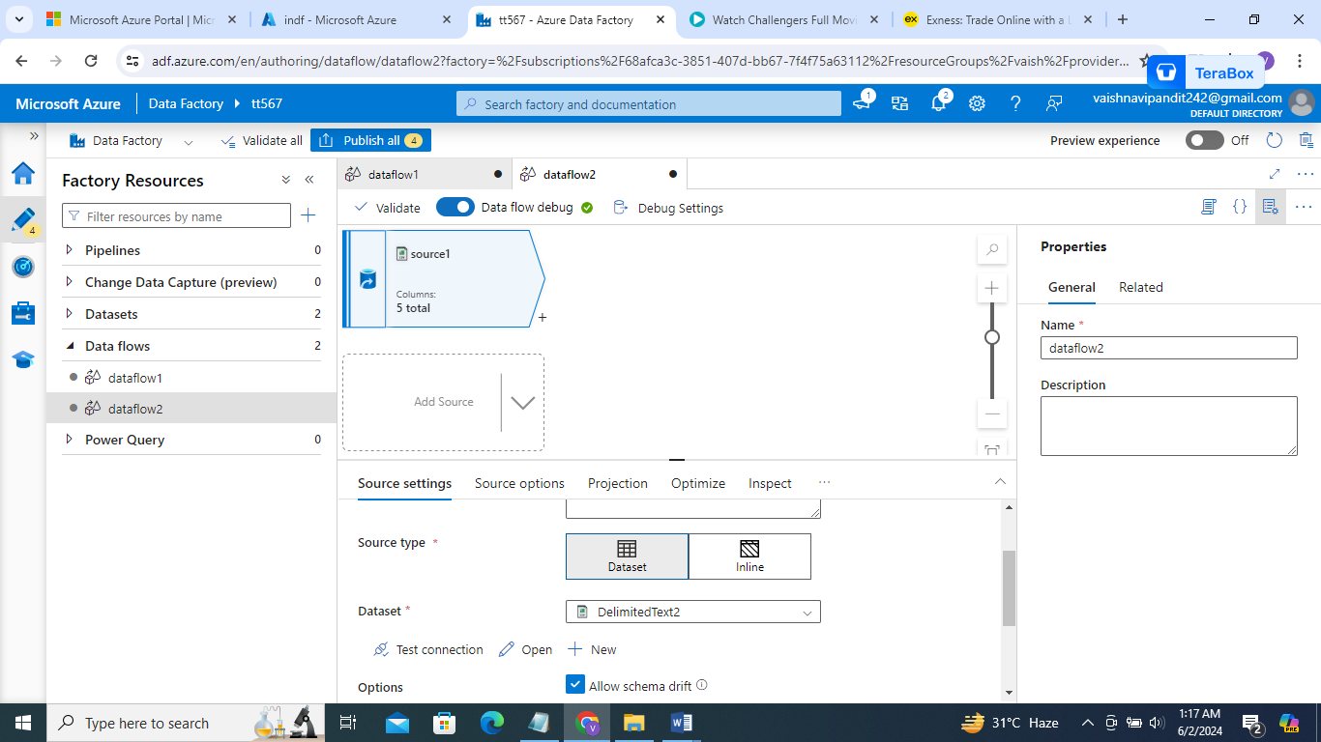

1. Create aggregate activity to groupby departemt wise and then gender wise so will get the format like table 1

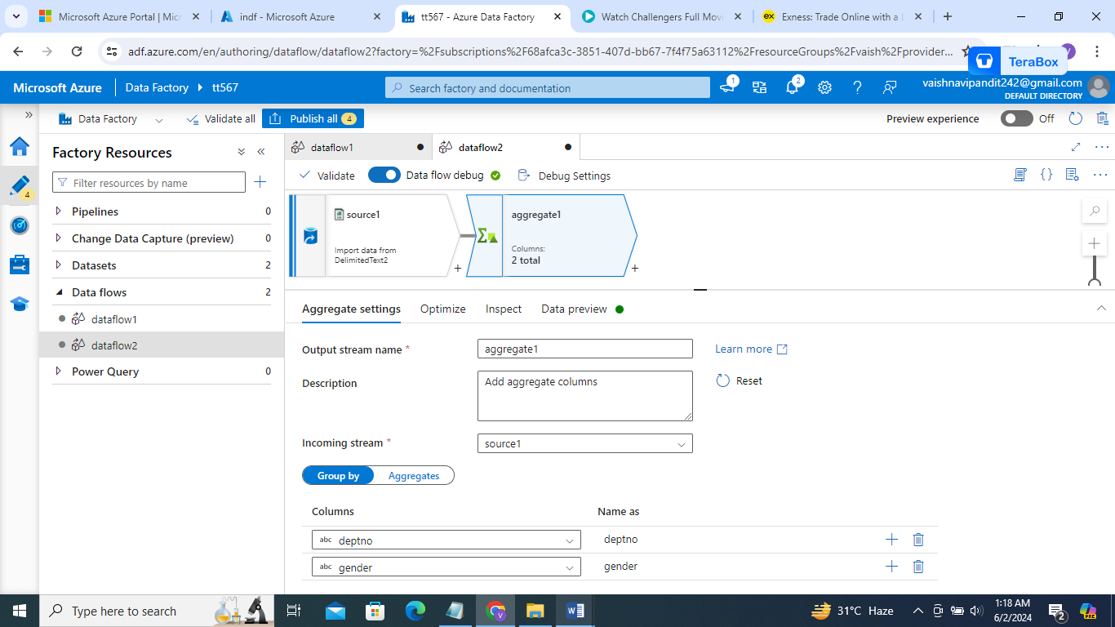

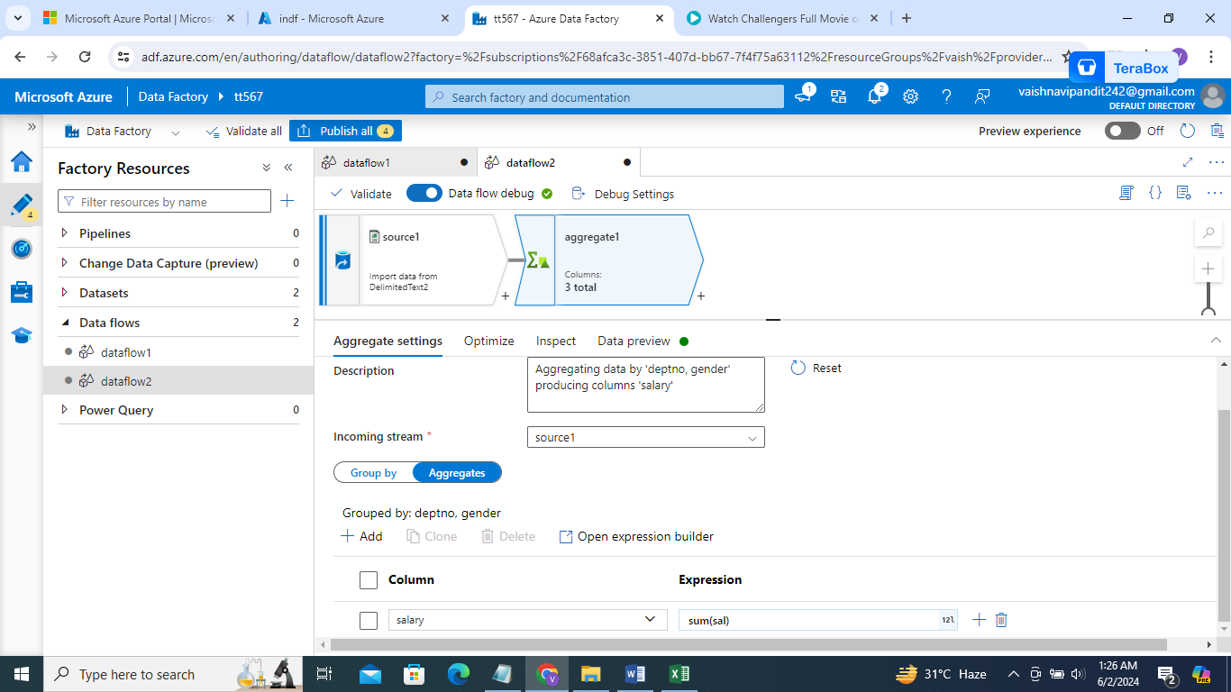

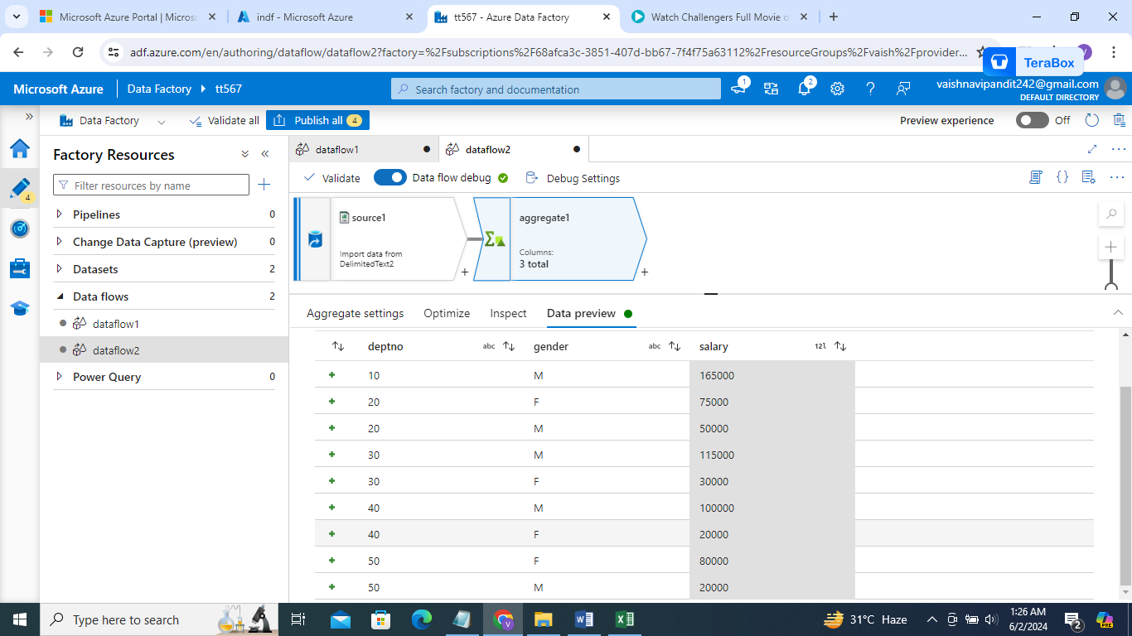

1. Now create pivot go on + after aggregate click on that and select pivot

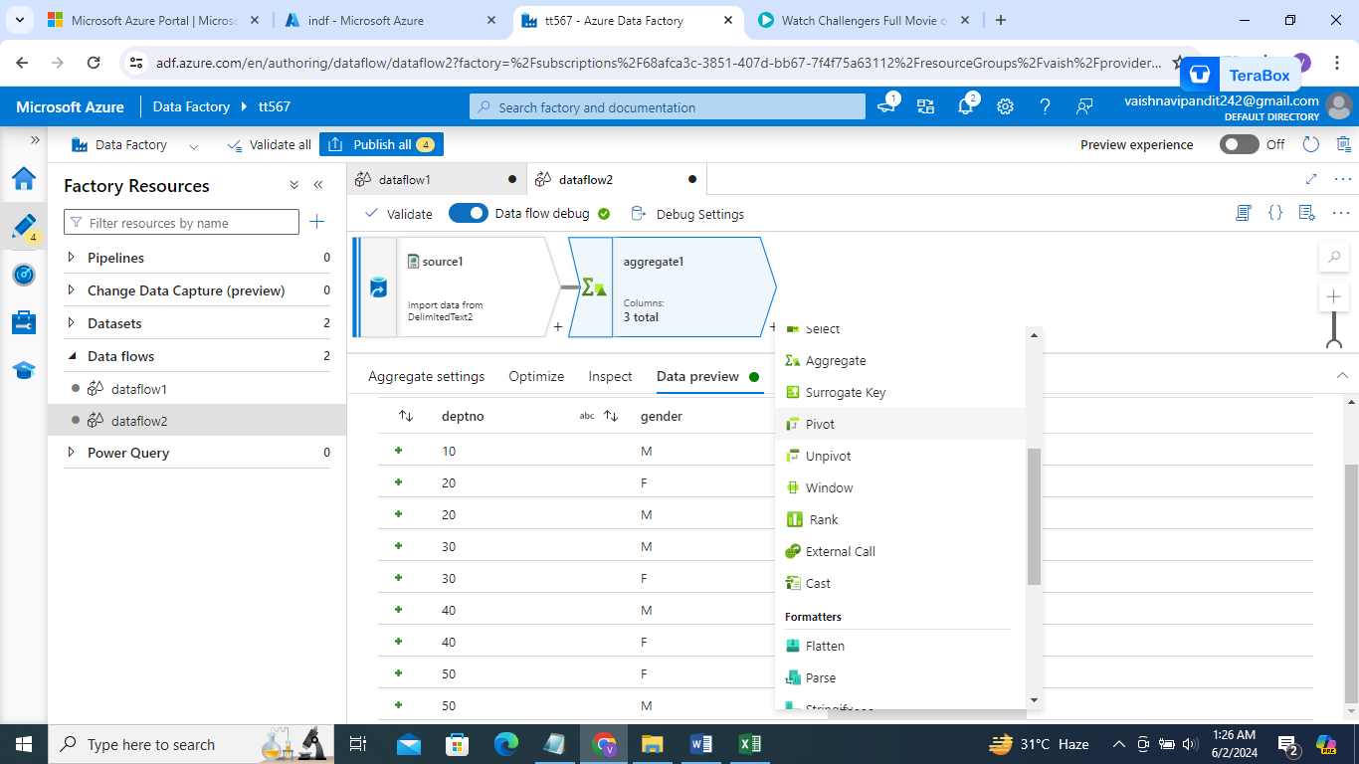

1. Enter pivot

Group by=dept no

Pivot key gender

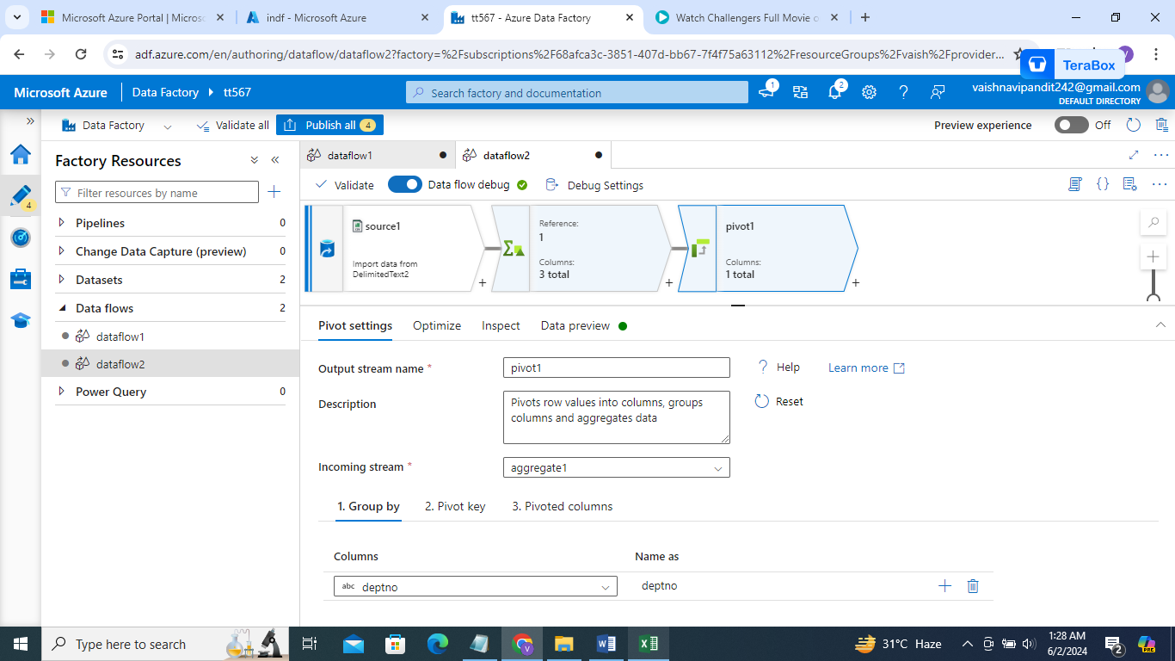

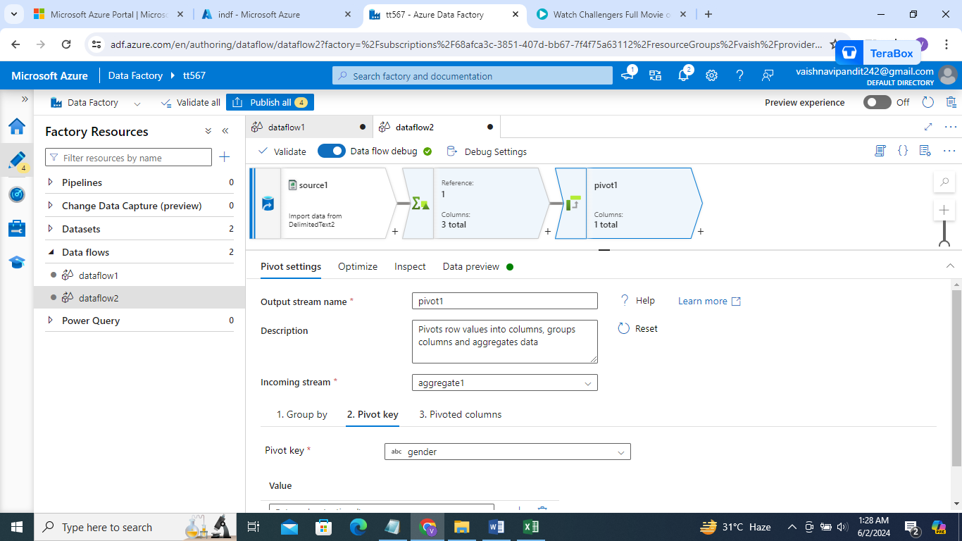

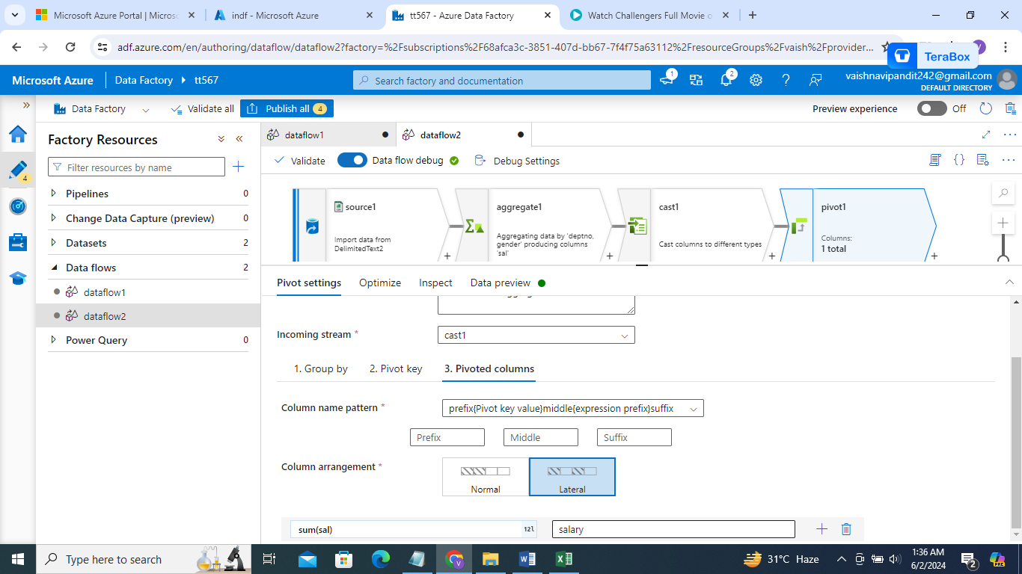

1. Go see preview

